How it works...

validation/success URL, and you’ll get the following:

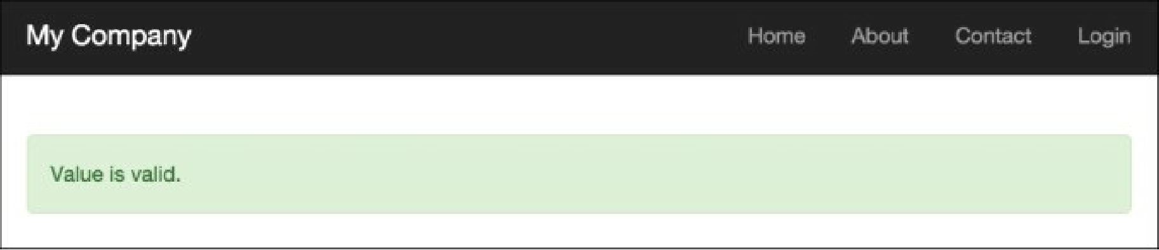

8. Run the failure action of the adhocvalidation controller by opening the index.php?r=adhoc- validation/f ailure URL, and you’ll get the following:

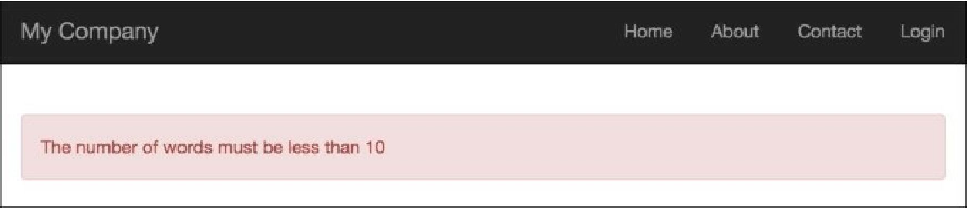

First, we created a standalone validator that checks the number of words by using the standard str_word_count PHP function, and then demonstrated two validator use cases:

* Using the validator as a validation rule in the Article model
* Using the validator as an ad hoc validator

The validator has a size attribute, which sets the maximum value for the number of words.

See also

For further information, refer to the following URLs:

* [http://www.yiiframework.com/doc-2.0/guide-input-va]idation.html](http://www.yiiframework.com/doc-2.0/guide-input-validation.html)
* <http://www.yiiframework.com/doc-2.0/guide-tutorial-corevalidators.html>